Lab-6

Order database

**Code:**

create database order_dab;

use order_dab;

create table Salesman

(salesman_id int primary key not null,

name varchar(25),

city varchar(25),

commission real);

create table Customer

(customer_id int primary key not null,

cust_name varchar(25),

city varchar(25),

grade int,

salesman_id int,

foreign key(salesman_id) references Salesman(salesman_id)on delete set null);

create table Orders(

order_no int,

purchase_amt real,

ord_date date,

customer_id int,

salesman_id int,

foreign key(customer_id) references Customer(customer_id) on delete cascade,

foreign key(salesman_id) references Salesman(salesman_id) on delete cascade);

insert into salesman values

(1000,"JHON","BANGALORE",25),

(2000,"RAVI","BANGALORE",20),

(3000,"KUMAR","MYSORE",15),

(4000,"SMITH","DELHI",30),

(5000,"HARSHA","HYDRABAD",15);

insert into Customer values

(10,"PREETHI","BANGALORE",100,1000),

(11,"VIVEK","MANGALORE",300,1000),

(12,"BHASKAR","CHENNAI",400,2000),

(13,"CHETHAN","BANGALORE",200,2000),

(14,"MAMATHA","BANGALORE",400,3000);

insert into Orders values

(50,5000,"2017-05-04",10,1000),

(51,450,"2017-01-20",10,2000),

(52,1000,"2017-02-24",13,2000),

(53,3500,"2017-04-13",14,3000),

(54,550,"2017-03-09",12,2000);

select * from salesman;

select *from customer;

select * from orders;

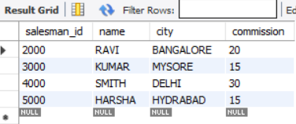

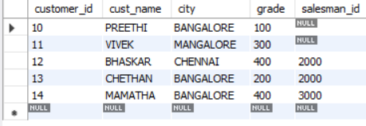

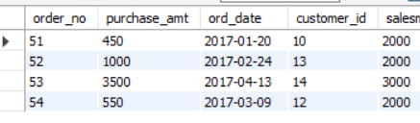

**1.** select count(*) from Customer

where grade>(select avg(grade) from Customer where city="BANGALORE");

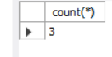

**2.**

select s.salesman_id,s.name from Salesman s,Customer c

where

s.salesman_id=c.salesman_id

group by c.salesman_id

having count(*)>1;



**3**.

SELECT s.salesman_id, name, cust_name, commission

FROM Salesman s, Customer c

WHERE s.city = c.city

UNION

SELECT salesman_id, name, 'NO MATCH', commission

FROM Salesman

WHERE NOT city = ANY

(SELECT city

FROM Customer)

ORDER BY 2 DESC;

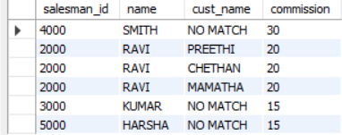

**4.**

create view HighestOrder as

select o.ord_date,s.salesman_id,s.name from Salesman s,Orders o

where s.salesman_id=o.salesman_id and

o.purchase_amt= (select max(purchase_amt) from Orders where ord_date=o.ord_date);

select * from HighestOrder;

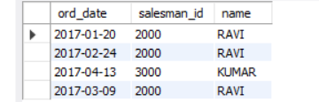

**5.**

delete from Salesman where salesman_id=1000;

select * from Salesman;

select * from Orders;

select * from Customer;

